Title: Jumanji: The Next Level

Director: Jake Kasdan

Year Released: 2019

Cast:

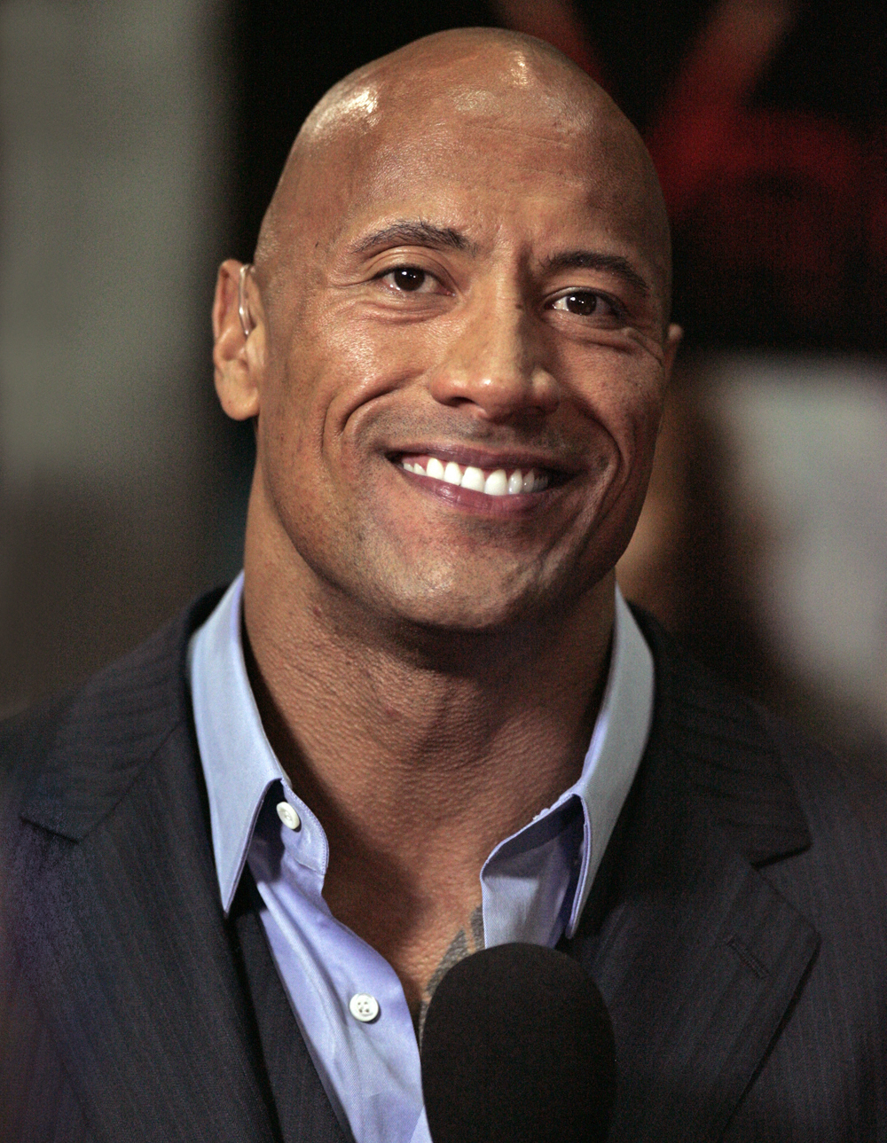

[Dwayne Johnson](https://en.wikipedia.org/wiki/Dwayne_Johnson) as Dr. Xander "Smolder" Bravestone: Eddie's avatar

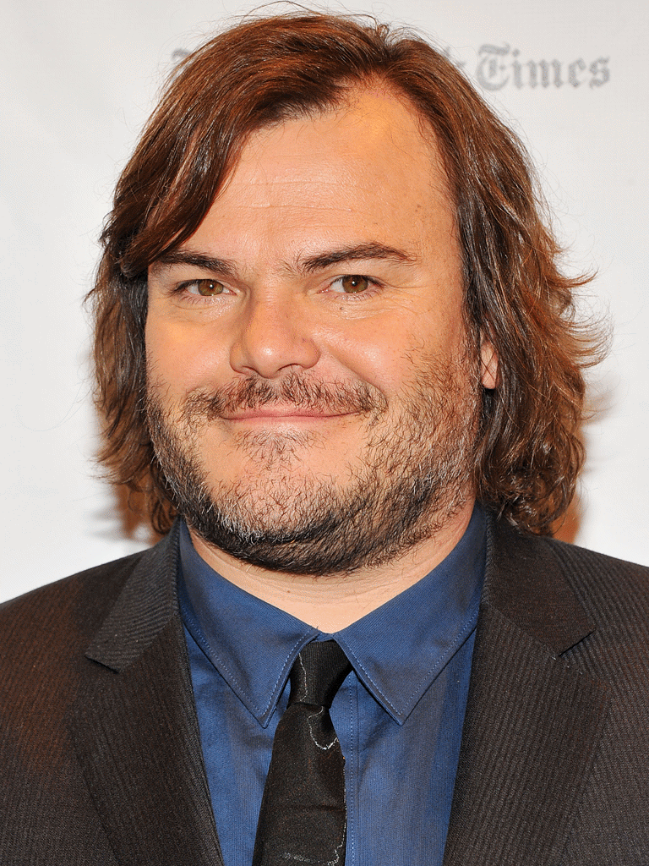

[Jack Black](https://en.wikipedia.org/wiki/Jack_Black) as Professor Sheldon "Shelly" Oberon: Fridge's avatar

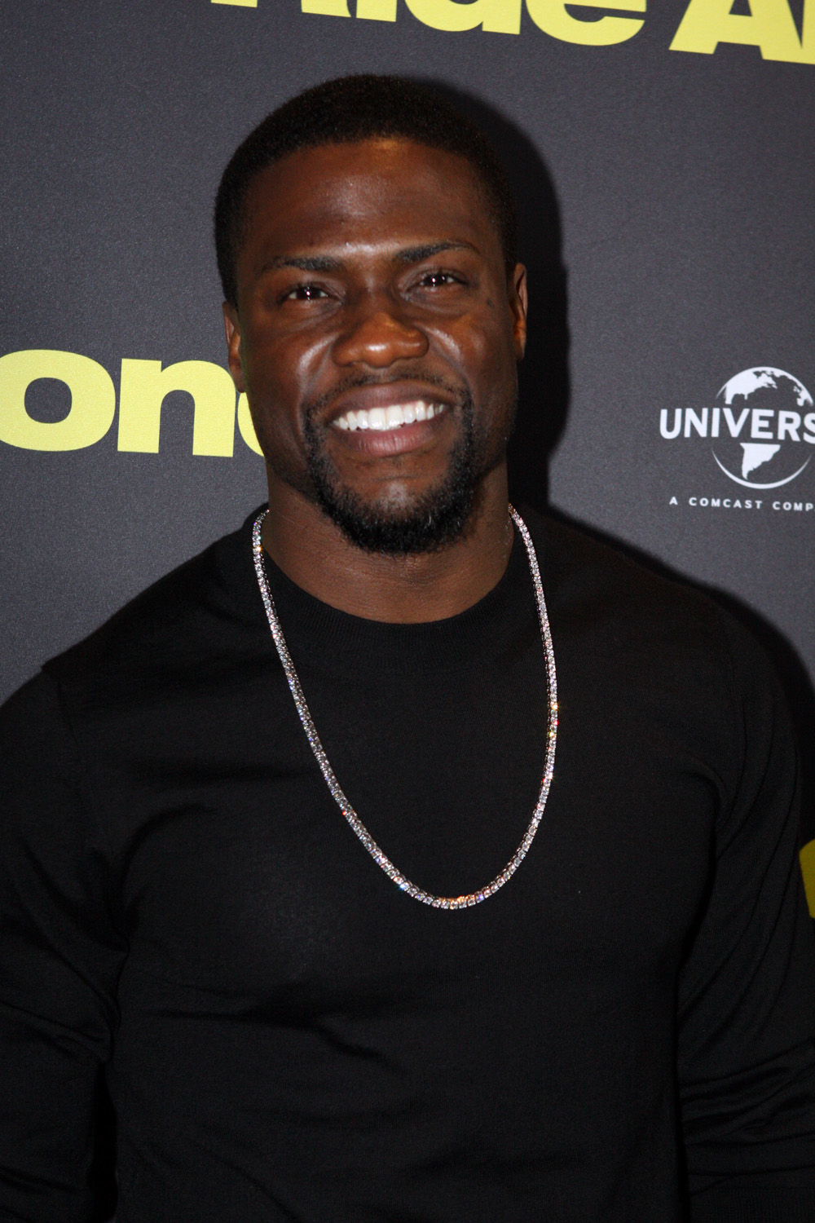

[Kevin Hart](https://en.wikipedia.org/wiki/Kevin_Hart" \o "Kevin Hart) as Franklin "Mouse" Finbar: Milo's avatar



[Karen Gillan](https://en.wikipedia.org/wiki/Karen_Gillan) as Ruby Roundhouse: Martha's avatar



[Awkwafina](https://en.wikipedia.org/wiki/Awkwafina) as Ming Fleetfoot

Synopsis :

In 2019, three years after their [adventure in Jumanji](https://en.wikipedia.org/wiki/Jumanji:_Welcome_to_the_Jungle), Spencer Gilpin, Anthony "Fridge" Johnson, Martha Kaply, and Bethany Walker lead different lives, but plan a reunion brunch in Brantford, [New Hampshire](https://en.wikipedia.org/wiki/New_Hampshire) that year. Spencer, apprehensive of the meeting due to depression, contemplates returning to Jumanji where he had purpose, and spends his first night looking over the broken video-game system he held onto. The following day, his friends visit his home, meeting with Spencer's grandfather Eddie, who is recovering from hip surgery, and Eddie's former friend and business partner Milo Walker, who is visiting for an unknown reason. Learning that they have no idea where Spencer is, the group search the house, and find the Jumanji game partially repaired in the basement. Realising Spencer returned to the game, his friends decide to follow him.The game malfunctions when starting up, sucking in only Fridge and Martha, along with Eddie and Milo, forcing Bethany to contact fellow Jumanji player Alex Vreeke for help. Inside the game, Martha finds herself as her [avatar](https://en.wikipedia.org/wiki/Avatar_(computing)) Ruby Roundhouse, yet Fridge becomes Bethany's avatar Professor Sheldon Oberon, while Eddie and Milo become avatars Dr. Smolder Bravestone and Franklin "Mouse" Finbar respectively. After instructing Eddie and Milo on the game's rules, the group encounter [non-player character](https://en.wikipedia.org/wiki/Non-player_character) Nigel Billingsley, the game's guide, who reveals that since its last use, Jumanji is suffering from a massive drought. To leave the game, Nigel reveals that the group must recover the "Falcon Jewel" – a magical necklace stolen by warlord Jurgen the Brutal – which can end the drought if brought before sunlight and uttering "Jumanji".